Name: …………………..  Grade 5 | Unit 20: Which one is more exciting, life in the city or life in the countryside?
BÀI TẬP CƠ BẢN
Exercise 1: Look and complete.
 |  | 
1. b _ _ _ |  | 2. n_ _ _ y
 |  | 
3. _ _ _ y |  | 4. s _ _ _
 |  | 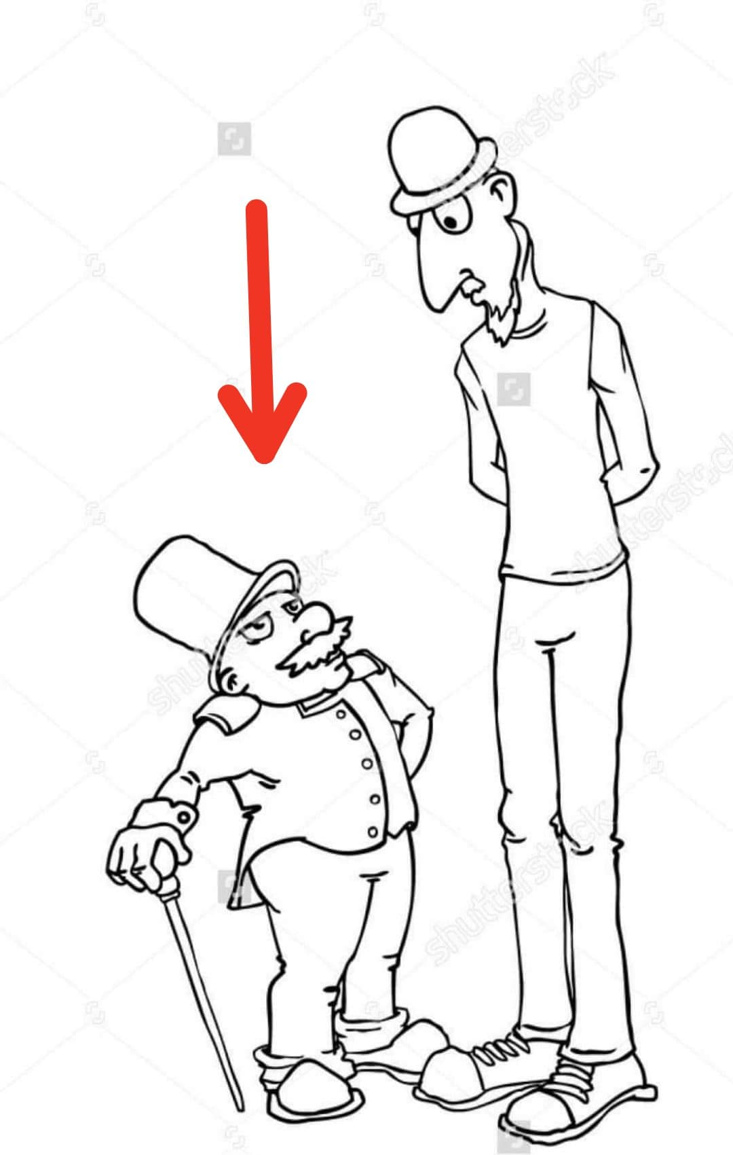
5. m _ _ _ t _ _ _ |  | 6. s _ _ _ _
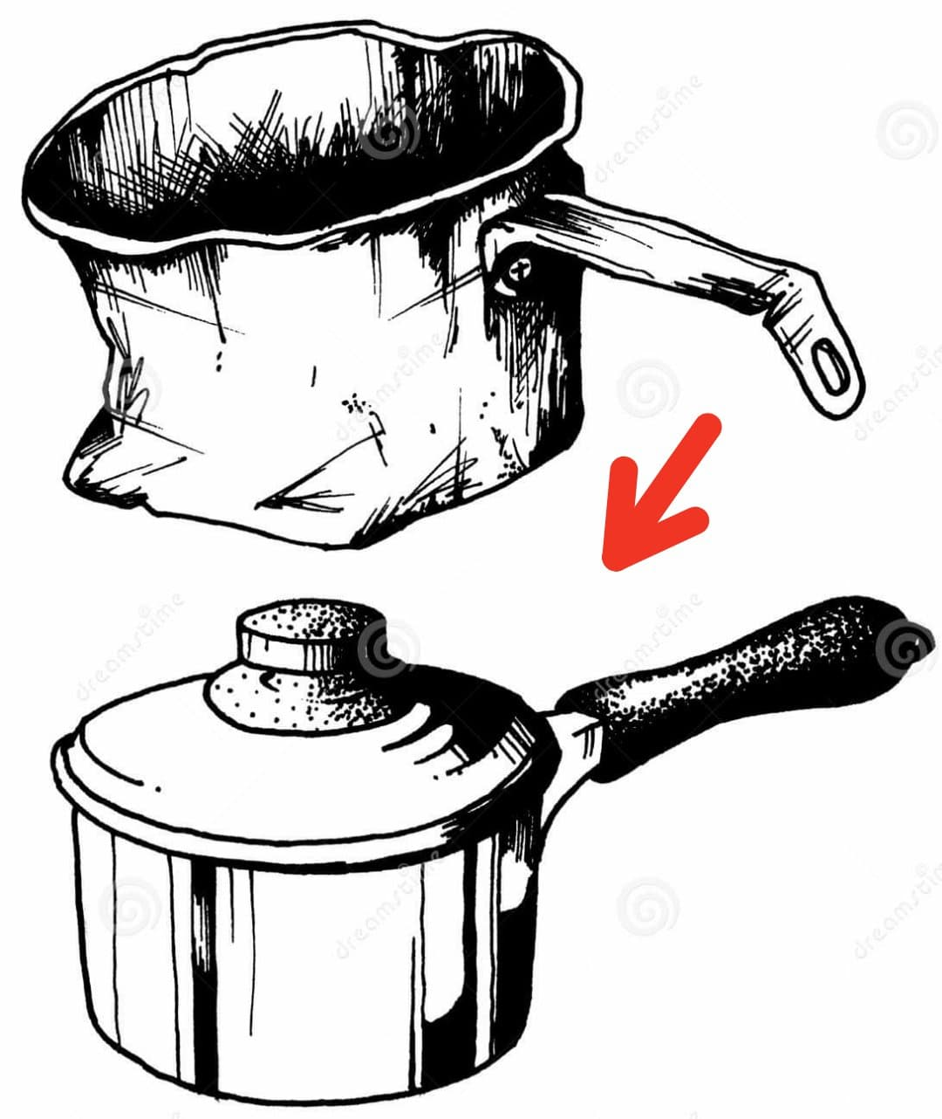 |  | 
7. _ _ w |  | 8. q _ _ _ t
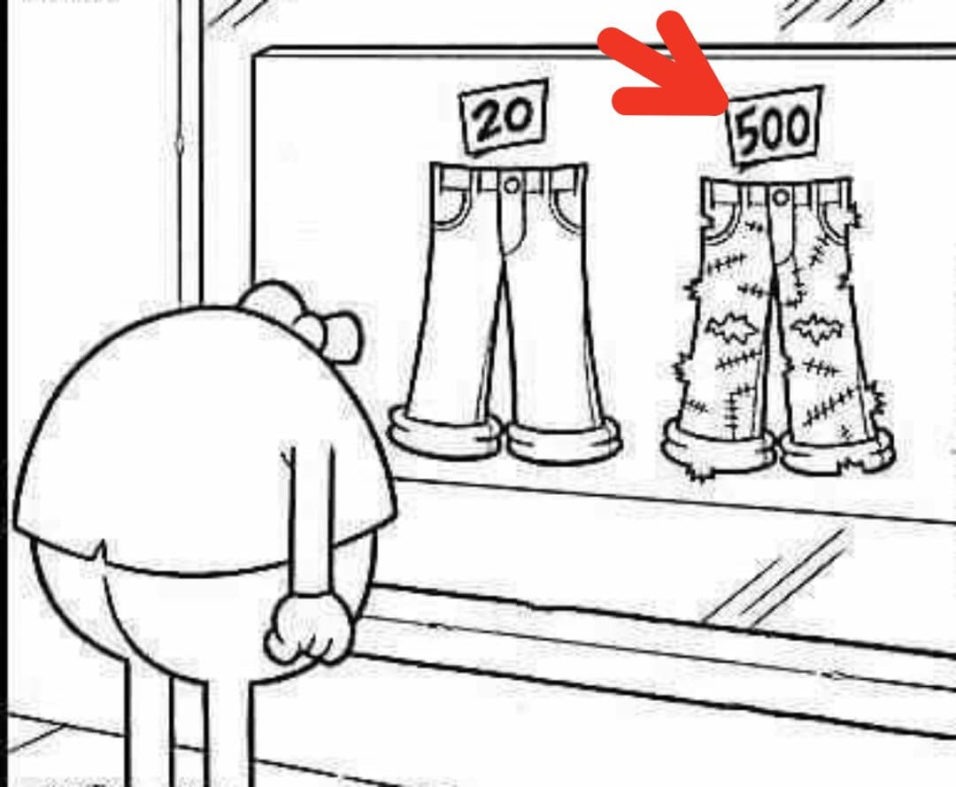 |  | 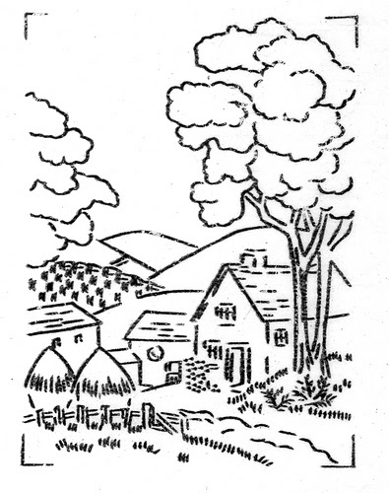
9. e _ _ _ns_ _ _ |  | 10. _ _ _ntry_ _ _ _

Exercise 2: Look and answer.
 | 1. Which one is more expensive, the new car or the old car?  =>…………………………………………………………
 | 2. Who is faster, the woman or the man?  =>…………………………………………………………
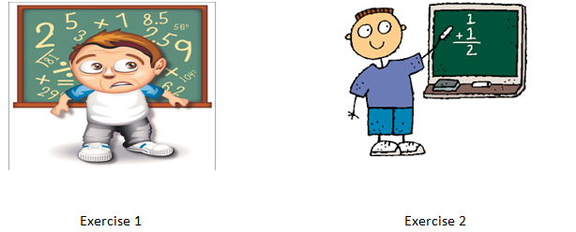 | 3. Which one is more difficult, Exercise 1 or Exercise 2?  =>………………………………………………………..
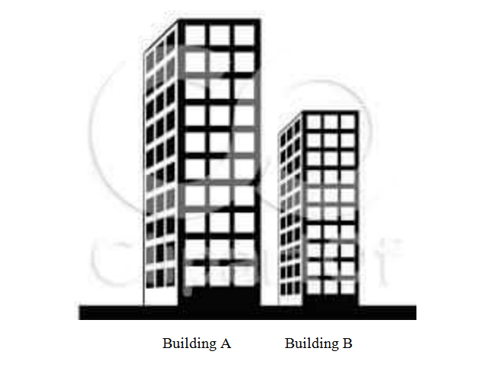 | 4.Which one is higher, Building A or Building B?  =>……………………………………………………….
 | 5. Who is weaker, the man or the boy?  =>…………………………………………………………

Exercise 3: Match.
1. What’s Hue Imperial City like? | A. I’m going to Da Lat.
2. Which one is more exciting, Hanoi or Ho Chi Minh City? | B. It’s very beautiful.
3. Which one is smaller, New York or Sydney? | C. I live in Nha Trang.
4. Where are you going this summer? | D. I think Ho Chi Minh City is.
5. Where do you live? | E. I think Sydney is.
DGGGD
1………2……….3………..4…………5………….
Exercise 4: Read and complete.
larger
beautiful
visit
like
three
Hoa: | Where are you going this summer?
Nam: | I’m going to (1)………………. Nha Trang.
Hoa: | What’s it (2)………………?
Nam: | It’s very (3)………………..?
Hoa: | Who are you going (4)………………………with ?
Nam: | I’m going there with my parents.
Hoa: | Which one is (5)………………… Nha Trang or Ho Chi Minh City?
Nam: | I think Ho Chi Minh City is

Exercise 5: Circle the correct answer.

1. This house is……………………..than that one. (big / biger / bigger / more big)
sfsfs
2. Which one is……………………….…..……the shirt or the skirt?
(expensive / expensive / more expensive)
sfsfs
3. She’s going to stay…………………. Home. (at / in / on)
sfsfs
4. Da Lat is more……………………..….than Hanoi.(bigger / narrow /peaceful)
sfsfs
5…………………………do your grandparents live? (What / When / Where)
sfsfs
6……………………………place do you want to visit? ( Which / Where / How)

BÀI TẬP NÂNG CAO

Exercise 6: Complete the table.

ADJECTIVE | COMPARATIVE
good
polluted
intelligent
high
short
attractive
nice
quiet

Exercise 7: Give the correct form of the adjectives in brackets.

1. New York City is (large) …........................................ than Sydney.
fggfb
2. Ha Long City is (beautiful) ….................................... than Nha Trang.
fggfb
3. Nam is (young) ….................................... than Hung.
fggfb
4. Is she as (tall) ….................................. as her sister?
fggfb
5. This lesson is (boring) …............................ than that one.
fggfb
6. The food here is ( delicious) …................................ than that in my hometown.

7. Her shirt is (cheap) …................................ than my shirt.
fggfb
8. Which one is (good) …............................ life in Ha Noi or life in Ho Chi Minh City?

Exercise 8: Use the words given to make sentences.

1. Which/ one/ noisier/ Hanoi/ Da Nang/ ?
→……………………………………………………………………………………
2. Ho Chi Minh City/ big/ city/ your country/ ?
→……………………………………………………………………………………
3. What/ he/ going/ do/ next week/ ?
→……………………………………………………………………………………
4. Where/ Vietnam/ your parents/ live/ ?
→……………………………………………………………………………………
5. I think/ life / the city/ busy/ life/ countryside/ .
→……………………………………………………………………………………
6. she/ want/ live/ this city/ because/ it/ big/ exciting/ .
→……………………………………………………………………………………

Exercise 9: Rewrite the sentences beginning with the given words.

1. Life in the city is noisier than life in the countryside.
fff
=> Life in the countryside .......................................................................................
fff
2. Hanoi is smaller than Ho Chi Minh City.
fff
=> Ho Chi Minh City ...............................................................................................
fff
3. Nam is taller than Hung.
fff
=> Hung ...................................................................................................................
fff
4. The ruler is longer than the pencil.
fff
=> The pencil ...........................................................................................................
fff
5.This house is newer than that house.
fff
=> That house…..........................................................................................................

Exercise 10: Read and answer.

My name's Nam. I live with my parents in Ho Chi Minh City, a very big city in Vietnam. There are a lot of people living here, so it is very crowded and noisy. It also has lots of high building. Life in this city is more exciting than life in my hometown.
During summer holidays, my parents and I often go back to our hometown, Nghe An.
It is central Vietnam. It is smaller than Ho Chi Minh City. Life here is more quiet than life in the city because there are not so many people and much traffic. I think that living in the countryside is easier than living in a big city because things are cheaper and people are friendly.

1. Where does Nam lives?

=>.................................................................................................................................

2. What is Ho Chi Minh City like?

=>.................................................................................................................................

3. Where does he often go during summer holidays?

=>.................................................................................................................................

4. Which one is bigger, Ho Chi Minh City or Nghe An?

=>.................................................................................................................................

5. Which one is more quiet, Ho Chi Minh City or Nghe An?

=>.................................................................................................................................

6. Does he think that life in a big city is easier than in the countryside?

=>.................................................................................................................................

